 | Orange Township Public Schools  Lincoln Avenue School  Mr. Frank Iannucci, Principal | 
Gerald Fitzhugh, II, Ed.D.
Superintendent of Schools

Mr. Patrick Yearwood, Assistant Principal
Ms. Isabel Colon, Assistant Principal
Mr. Noel Cruz, Dean of Students
Student Schedule
SY: 2020-2021

Homeroom Teacher: Ms. Gallmon
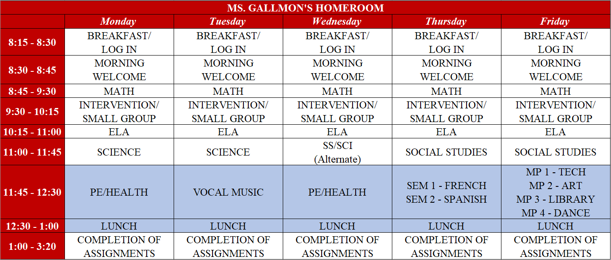

Google Meet Link: | https://meet.google.com/lookup/g4v5z2y27w
Google Classroom Code: | 7jureyq

Student Expectations
- “Arrive” on time to class every day and be prepared to learn
- Complete all assignments by indicated due dates (utilize time wisely)
- Engage in all classroom lessons and/or activities; be present during synchronous instruction
- Dress appropriately for the school day (no pajamas)
- Participate in all school spirit activities
- Behave appropriately and demonstrate LINCOLN LEADERS

